The French Revolution

(NB: Mote this work is already on the D6)
In 1789, in the wake of early morning, the city of Paris was in a state of alarm. Rumours spread that the King would open fire upon the citizens. People started gathering and they started breaking a number of government buildings in search of arms. The commander of the Bastille was killed in the armed fight and the prisoners were released. People hated the Bastille as it stood for the despotic power of the king. People protested against the high price of bread. A new chain of events began which led to the execution of the King in France.

French Society During the Late Eighteenth Century
Louis XVI, in 1774, ascended the throne of France. Financial France was drained because of the war. France, Under Louis XVI, helped the thirteen American colonies to gain their independence from Britain. Taxes were increased to meet regular expenses, such as the cost of maintaining an army, the court, running government offices or universities. The country of France was divided into three estates in the eighteenth century. The feudal system was part of the society estates dated back to the middle ages. 90 percent of the population was dominated by peasants but only a small number of them owned the land they cultivated. 60 percent was owned by nobles, the Church and other richer members of the third estate. The clergy and the nobility, members of the first two estates enjoyed certain privileges by birth. These groups of members were exempted from paying taxes and enjoyed feudal privileges. All members of the third estate had to pay taxes to the state which included a direct tax, called taille, and a number of indirect taxes which were levied on articles of everyday consumption like salt or tobacco.

The Struggle to Survive
Increase in population led to a rapid increase for food grains. Production of grains could not keep pace with the demand due to which the price of bread rose rapidly. Due to low wages paid to the labourers the gap between the poor and the rich widened. Things became worse whenever drought or hail reduced the harvest.

A Growing Middle Class Envisages an End to Privileges
Peasants used to participate in revolts against taxes and food scarcity. Group of the third estate had become prosperous and had access to education and new ideas. In the eighteenth century, new social groups emerged, termed the middle class, who earned their wealth through expanding overseas trade and by manufacturing woollen and silk textiles that were either exported or bought by the richer members of society. The third estate included professions such as lawyers or administrative officials. A person’s social position was dependent on their merit.
All of these were educated and believed that no group in society should be privileged by birth. Rather, a person’s social position must depend on his merit. A new form of government was proposed by Rousseau based on a social contract between people and their representatives.
Similarly, Montesquieu proposed a division of power within the government between the legislative, the executive and the judiciary. In the USA, this model of government was put into force. Louis Louis XVI planned to impose further taxes to meet the expenses.

The Outbreak of the Revolution
In France, the monarch didn’t have the power to impose taxes. They had to call a meeting of the Estates-General, a political body to which the three estates sent their representatives, to pass proposals for new taxes. Louis XVI, on 5 May 1789, called an assembly to pass proposals for new taxes. Representatives from the first and second estates were present and the third estate was represented by its prosperous and educated members. According to the principle each estate had one vote. But, representatives from the third estate demanded each member would have one vote. The demand was rejected so members of the third estate walked out to protest. They swore not to disperse till a constitution drafted for France that would limit the powers of the monarch.
Due to the severe winter, bread price rose and people had to spend hours in long queues. Rumours spread that the lords of the manor hired bands of brigands to destroy the ripe crops. In fear, peasants started looting hoarded grain and burnt down documents containing records of manorial dues. Nobles fled from their homes. Louis XVI accorded recognition to the National Assembly and accepted the principle that his powers would from now on be checked by a constitution. The Assembly passed a decree abolishing the feudal system of obligations and taxes on 4 August 1789. Tithes were abolished and lands owned by the Church were confiscated.

France Becomes a Constitutional Monarchy
In 1791, The National Assembly completed the draft of the constitution and its main object was to limit the powers of the monarch. These powers were now separated and assigned to different institutions – the legislature, executive and judiciary. France became a constitutional monarchy.
Citizens voted for a group of electors, who in turn chose the Assembly, but unfortunately, not every citizen had the right to vote. Men above 25 years of age who paid taxes equal to at least 3 days of a labourer’s wage were entitled to vote. The Constitution began with a Declaration of the Rights of Man and Citizen. Rights such as the right to life, freedom of speech, freedom of opinion, equality before law, were established as ‘natural and inalienable’ rights, that is, they belonged to each human being by birth and could not be taken away.

France Abolishes Monarchy and Becomes a Republic
In April 1792, the National Assembly voted for a war against Prussia and Austria. Marseillaise became the national anthem of France. While men were away fighting at the war, women took care of their families. Large sections of the population demanded that the revolution had to be carried further, as the Constitution of 1791 gave political rights only to the richer sections of society. Political clubs were formed and among them, Jacobins became the most successful club. Members of the Jacobin club included small shopkeepers, artisans such as shoemakers, pastry cooks, watch-makers, printers, as well as servants and daily-wage workers. Jacobin members started wearing long striped trousers similar to those worn by dockworkers. These Jacobins were called the sans-culottes, literally meaning ‘those without knee breeches’. On August 10 1792, Jacobins stormed the Palace of the Tuileries and held the king hostage for several hours. Elections were held and all men of 21 years and above got the right to vote. Monarchy was abolished on 21 September 1792 and France was declared a republic. Louis XVI was sentenced to death by a court on the charge of treason.

The Reign of Terror
The period from 1793 to 1794 is referred to as the Reign of Terror. People whom Robespierre saw enemies of the republic were arrested, imprisoned and then tried by a revolutionary tribunal. If they were declared guilty by the court then they were guillotined. The guillotine is a device consisting of two poles and a blade with which a person is beheaded, named after Dr Guillotin. Laws were issued to place a maximum ceiling on wages and prices. Meat and bread were rationed. Expensive white flour was forbidden to use. Equality was practised through forms of speech and address. All French men and women were addressed as Citoyen and Citoyenne (Citizen). In July 1794, he was convicted by a court arrested and the next day sent to the guillotine.

A Directory Rules France
Fall of the Jacobin government allowed the wealthier middle classes to seize power. According to the new constitution, non-propertied sections of society denied voting. It provided for two elected legislative councils. The government appointed a Directory, consisting of executives made up of five members. Political instability paved the way for a military dictator, Napoleon Bonaparte.

Did Women have a Revolution?
Women were active participants from the beginning which brought important changes in the country France. Women from the third estate had to work for a living and they didn’t have access to education or job training. Daughters of nobles of the third estate were allowed to study at a convent. Working women also had to care for their families. Compared to men their wages were lower. Women also started their political clubs and newspapers. The Society of Revolutionary and Republican Women was one of the most famous women’s clubs. They demanded equal political rights as men, the right to vote and to hold political office. The revolutionary government introduced laws to improve the lives of women. Schooling became compulsory, divorce made legal and they could run small businesses. During the Reign of Terror, the government closed women’s clubs banning their political activities. After much struggle, women in France in 1946 won the right to vote.

The Abolition of Slavery
Jacobin regime’s most revolutionary social reform was the abolition of slavery in the French colonies. In the seventeenth century, slavery trade began. Slaves were brought from local chieftains, branded and shackled and were packed tightly into ships for the three-month-long voyage across the Atlantic to the Caribbean. Slave labour met the growing demand in European markets for sugar, coffee, and indigo. Throughout the eighteenth century, there was little criticism of slavery in France. In 1794, the Convention legislated to free all slaves in the French overseas possessions. Napoleon introduced slavery after ten years. In 1848, slavery was abolished in French colonies.

The Revolution and Everyday Life
France during 1789 saw changes in the lives of men, women and children. Abolition of censorship happened in the summer of 1789. Declaration of the Rights of Man and Citizen proclaimed freedom of speech and expression to be a natural right. Freedom of press meant opposing views of events could be expressed. Plays, songs and festive processions attracted large numbers of people.

Conclusion
Napoleon Bonaparte crowned himself Emperor of France, in 1804 and introduced many laws such as the protection of private property and a uniform system of weights and measures provided by the decimal system. Napoleon was defeated at Waterloo in 1815. The ideas of liberty and democratic rights were the most important legacy of the French Revolution. Colonised peoples reworked on the idea of freedom to create a sovereign nation-state.

Now that you have read this summary do the source based activity that follows. DO NOT SUBMIT YOUR ANSWERS. ANSWERS WILL BE UPLOADED FOR SELF MARKING

Causes of the French Revolution source based activity

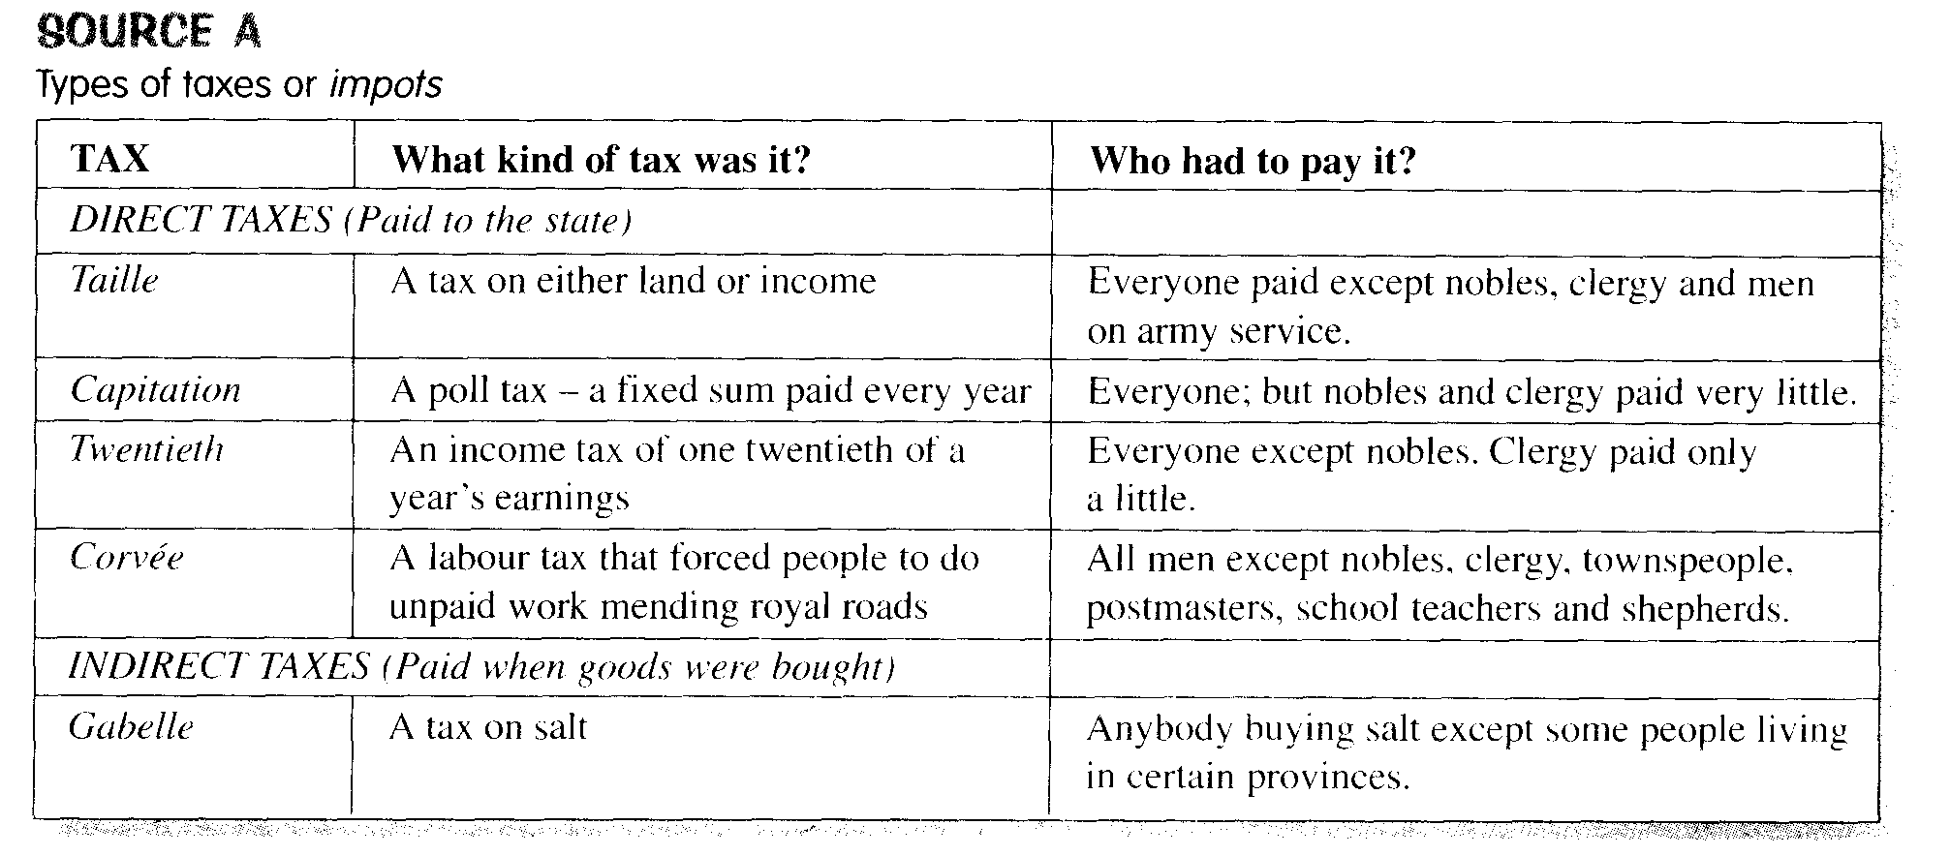
SOURCE B
A French cartoon, drawn in 1789, showing members of the three Estates.
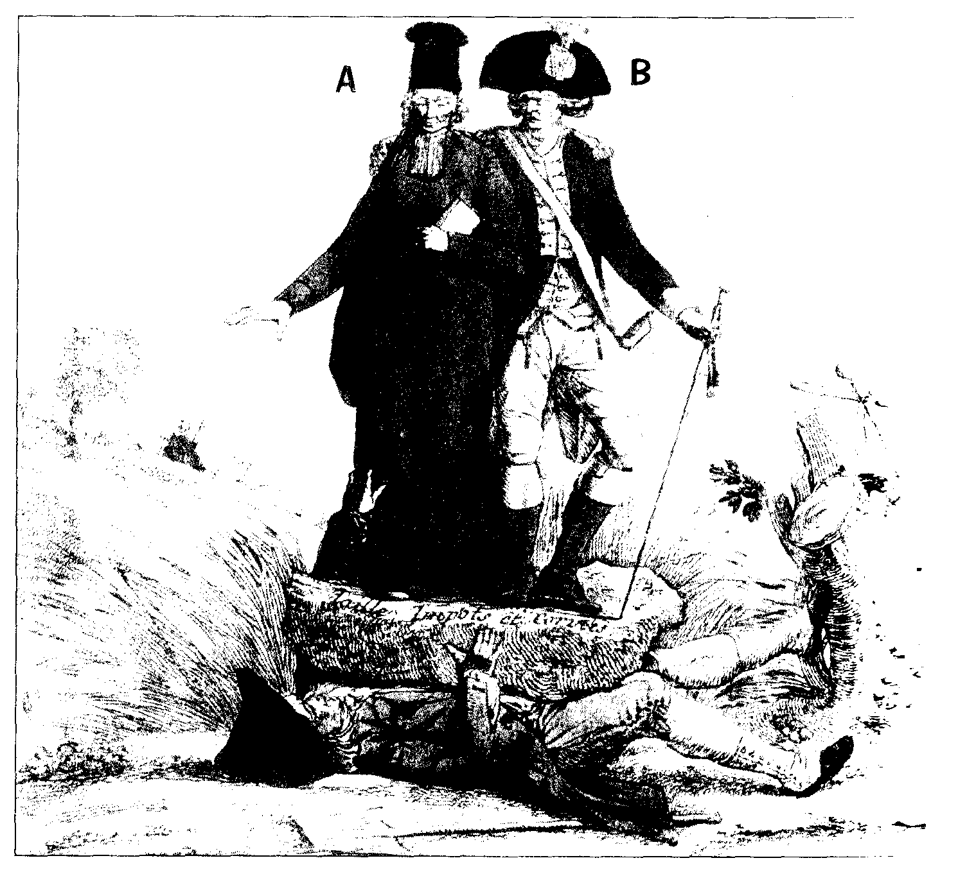

Source C
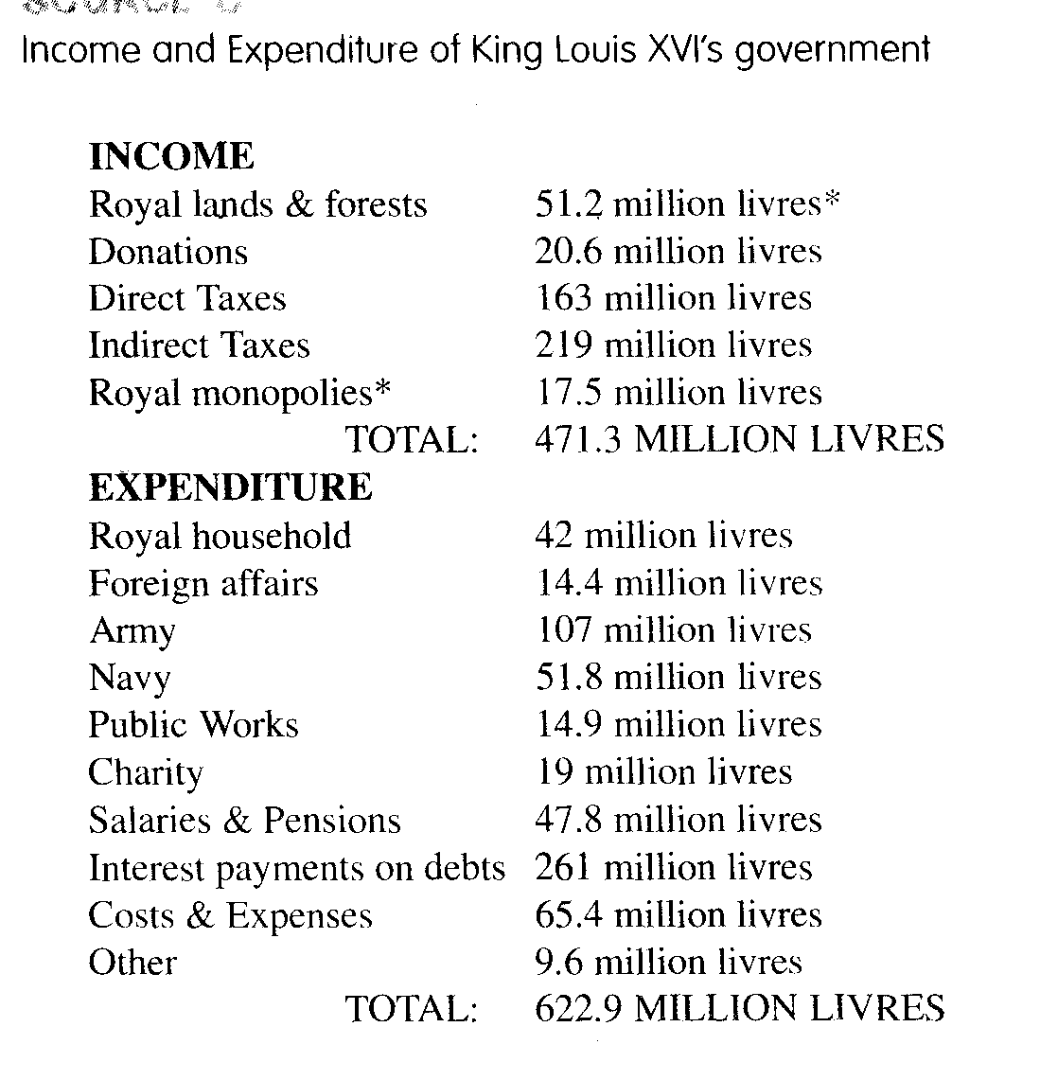
*Livres – French money
Source D
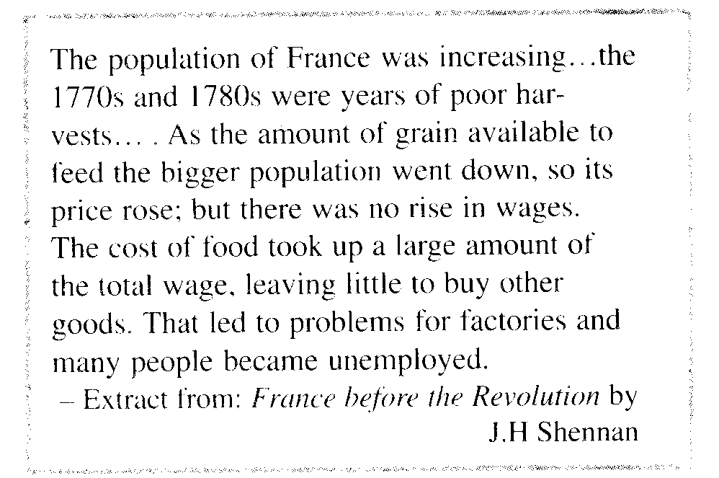

Extracted from: Shuters History: Grade 10, Ellis and Olivier (Eds.) (2005)

- Refer to source A.
- Which do you think is the worst tax? (1) Explain your answer (1x2).
- If you were a member of the Third Estate, how could you get out of paying the Taille?(1x2)
- Which tax would disrupt farming? (1x2)
- What information can you gain from this source to explain why certain people were unhappy in France before the Revolution? (2x2)
(11)
- Refer to source B
- Is source B a primary source? (1) Give a reason for your answer. (1x2)
- To which Estate do you think the man under the stone belongs? (1) Explain your answer. (1x2)
- Who do A and B represent? (2x1)
- How does the information in source A support the cartoonists view of France. (2x2)
- Explain what the cartoonist is saying about France in this cartoon. (2x2)
- Is source B reliable? (1) Give a reason for your answer. (1x2)
(19)
- Refer to source C
- What was the King's greatest expense? (1x1)
- From where did the king receive most of his income? (1x2)
- What information does this source give us about the financial situation in France? (2x2)
- If you were King Louis XVI's finance minister, what advice would you give him to get out of debt? (2x2) (11)
- Refer to source D
- Is source D a primary source? (1) Give a reason for your answer. (1x2)
- Why do you think the price of grain increased? (2x2)
- Why did many factory workers lose their jobs? (1x2)

DO NOT SUBMIT YOUR ANSWERS. ANSWERS WILL BE UPLOADED FOR SELF MARKING

